Properties of Metals & Non-Metals Name____________________#_____
Date___________________________
Class__________________________

The majority of our universe is comprised of metals. We (and all other organic life) are primarily comprised of non-metals. On the periodic table these elements can be found:
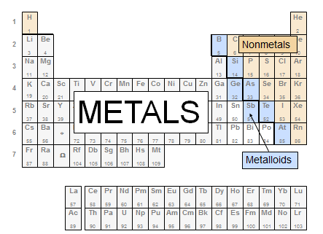
Metals and Non-metals have unique physical properties such as:
Luster |  |  |  | Is it shiny?
Metals- |  |  |  | Non-metals-
Magnetism |  |  |  | Is it magnetic?
Metals- |  |  |  | Non-Metals-
Conductivity |  |  |  | Does electricity or heat travel through it?
Metals- |  |  |  | Non-metals-
Malleability |  |  |  | Can it be hammered into thin sheets?
Metals- |  |  |  | Non-metals-
Ductility |  |  |  | Can it be drawn out into thin wires?
Metals- |  |  |  | Non-metals-
Reactivity (this is a chemical property) |  |  |  | Does it react well with other elements?
Metals- |  |  |  | Non-metals-
Normal state |  |  |  | Is it a solid, liquid or gas at room temperature?
Metals- |  |  |  | Non-metals-
Now we will evaluate some metals & non-metals to see for ourselves what these properties look like.
There are 4 lab stations you will need to visit, one at 2, 3, 5 & 6. Write yes/no, shiny/dull, or solid/liquid/gas for each element.
Property | Sulfur | Carbon | Copper |  | Aluminum | Gold | Oxygen | Iron
Luster
Magnetism
Conductivity
Malleability
Ductility
Normal State

