Interactions Among Living Things
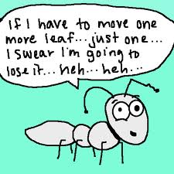
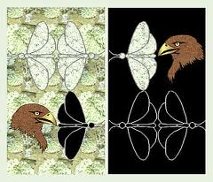
Every organism has some unique characteristics that enable it to live in its environment. In response to their environment, species evolve, or change over time. The changes that make organisms better suited to their environment occur by a process called natural selection. Individuals whose characteristics are best suited for their environment tend to survive and produce offspring. The offspring inherit those characteristics and also live to reproduce. Individuals that are poorly suited to the environment are less likely to survive and reproduce. The poorly suited characteristics may disappear from the population over time. The results of natural selection are adaptations, the behaviors and physical characteristics of species that allow them to live successfully in their environment. For example, the cheetah’s speed enables him to be able to catch his food. The hawk’s keen eye sees fish from far distances.
Moths can be varying colors of black or white. What happens to the moth population as the environment they are in changes?
Every organism has a variety of adaptations that are suited to its specific living conditions. These adaptations create a unique role for the organism in its ecosystem. An organism’s particular role, or how it makes its living, is called its niche. A niche includes the type of food the organism eats, how it obtains this food, which other species use it as food, when and how the organism reproduces, and the physical conditions it requires to survive. By having its own way to hunt for food, and the type of food it eats, and its own kind of shelter, organisms do not have to compete as much. However, two populations CANNOT occupy the same niche at
Niche -the job of an organism in an ecosystem
the same time in an ecosystem.
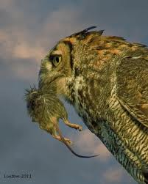
STOP: COMPARE the niche of three organisms in a forest ecosystem.

Some adaptations involve how organisms interact. There are three major types of interactions among organisms: competition, predation, and symbiosis. Competition is the struggle between organisms to survive in a habitat with limited resources which is the opposite of cooperation among members of a population as they try to help each other, as in when monkeys pick each other’s fleas or when wolves work together to capture their prey. Predation is an interaction in which one organism kills and eats another organism. The organism that does the killing is the predator. The organism that is killed is the prey. Predators have adaptations that help them catch and kill their prey. Prey organisms have adaptations that help them avoid being caught and eaten. Predation can have a major effect on the size of a population.
Predator and Prey
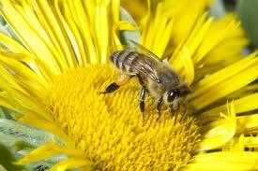
Symbiosis is a close relationship between two species that benefits at least one of the species. The three types of symbiotic relationships are mutualism, commensalism, and parasitism. Mutualism is a relationship in which both species benefit.
Mutualism

STOP: Look at the picture for mutualism. Why do you think this symbiotic relationship is mutualistic? Is this cooperation?
Write your answer here ___________________________________________
________________________________________________________________
Bee taking nectar from a plant.
________________________________________________________________
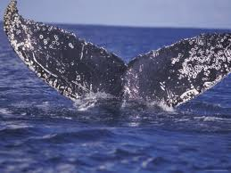
Barnacles getting a free ride on a whale's tail.

Commensalism is a relationship in which one species benefits and the other species is neither helped nor harmed. Barnacles are normally sessile or non-moving sea creatures. They rely on currents to bring food past them in order to eat. However, some barnacles have attached themselves to the sides of various sea life, such as whales. These barnacles benefit by receiving transportation all over the ocean which exposes them to more currents and feeding opportunities than they would normally experience. The whale neither benefits nor is harmed by the barnacles.
Commensalism
What does sessile mean? _____________________________________________________

Parasitism involves one organism living on or inside another organism and harming it. The organism that benefits is called a parasite, and the organism it lives on or in is called a host.
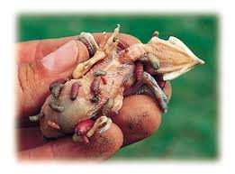
Why is parasitism sometimes called a non-mutualistic symbiotic relationship? _____________________________________________
________________________________________________________
Word analysis :
non-________________________________________________
mutualistic ___________________________________________
Parasitism
symbiotic _______________________________________________
Maggots from a fly on a blue martin.

Name______________________ Interactions Among Living Things
1. The changes that make organisms better suited to their environment occur by a process called _________________________________________.

2. What are the results of natural selection? ______________________________________________________

3. What are some examples of how adaptations enable organisms to survive better in their environments? _________________________________________________________________________________________

4. What is an organism’s niche?________________________________________________________________

5. True or False? Both lions and tigers can have their niche in the same ecosystem.
6. Name three ways organisms interact with each other in an ecosystem.
_______________________, _________________________, and _____________________________
7. What is the main reason organisms compete with each other in an ecosystem? ____________________________
8. Give an example of when organisms cooperate with each other. _________________________________
_________________________________________________________________________________________
9. _____________________ is an interaction in which one organism kills and eats another organism.

10. Give an example of a predator-prey relationship. Identify the predator and the prey.
__________________________________________________________________________________________________

11. What is symbiosis? ______________________________________________________________________________
12. Name and describe the three types of symbiotic relationships.
a._____________________________________________________________________________________
b._____________________________________________________________________________________
c._____________________________________________________________________________________

13. What does sessile mean? _________________________________________________________
14. A clown fish’s (Nemo) habitat is within a sea anemone’s tentacles. What kind of interaction is this? Explain.
___________________________________________________________________________________________
____________________________________________________________________________________________

