Conservation of Fossil Fuels
Fossil fuels are the materials that we use to meet our energy needs that are NOT renewable such as gas, coal, nuclear and (crude) oil/petroleum. It causes local air pollution and releases carbon dioxide that is a greenhouse gas into the atmosphere contributing to climate change. Since the discovery of crude oil it is estimated that we have already burned through half of our supply of crude oil in the United States which means we will become more and more dependent on supplies from the Middle East. As China and India become more and more industrialized they are increasing their consumption rate which has led to increased competition for fossil fuel resources and increased air pollution. Therefore switching from the usage of fossil fuels is necessary for environmental, safety, health and economic reasons. Here are some ideas about what YOU can do individually to COLLECTIVLY conserve (save) our energy resources.
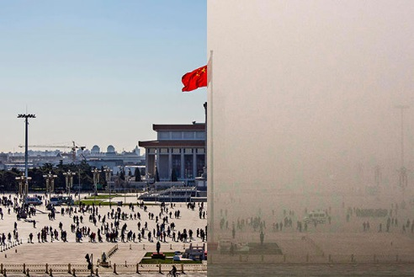
- RIDE A BIKE OR WALK MORE
Instead of taking a bus or driving a car, you can consider walking or cycling to your destination. It will not only help in reducing the usage of fossil fuels, but it will help to keep you healthy and fit. You can outfit yourself with safety gear and a mechanically sound bike and stick to Greenways wherever possible. You should always follow the same rules of the road that cars do.
- CONSIDER A HYBRID OR ELECTRIC CAR
Both of these cars need fewer fossil fuels to power them. They are the best option for you if you have to use a car to reach your destination until more viable and better options can be created that don’t rely as heavily on fossil fuels. These cars can be a little expensive so you can consider car share options which are becoming more and more available in cities throughout the US.
- TAKE PUBLIC TRANSPORTATION WHEREVER ABLE
In addition to using less fossil fuels if any, taking public transportation allows you to do other tasks like reading or working while “someone else” handles the driving. It is also a more economical choice.
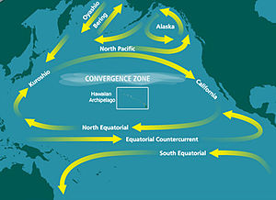
- REDUCE THE USE OF PLASTIC

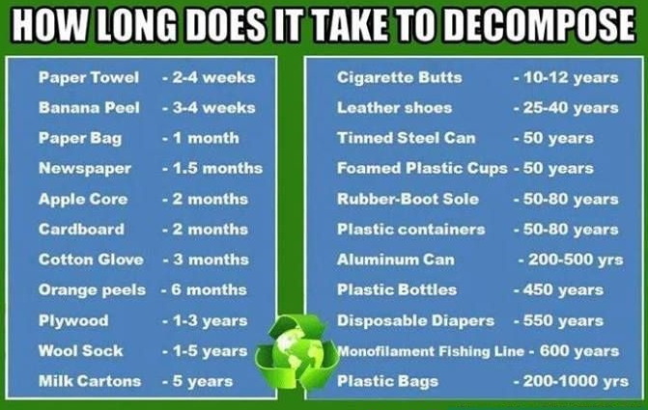
Most plastic is made from fossil fuels. Plastics do not break down very easily which create a problem with landfills. Some plastics even leach chemicals into our water, food and home environments. In order to reduce the use of fossil fuels and improve the health of your ecosystems and your health, using less plastic is the best choice! You can buy or make reusable bags and leave some bags in your car, bike or purse for shopping. Americans used 50 billion plastic bottles last year alone, only 23% of which was recycled, meaning all the rest of them wound up in landfills or even worse perhaps the ocean gyres. In the Pacific Ocean there is a garbage patch TWICE THE SIZE OF TEXAS! You can reduce the amount of plastic bottle waste by using a reusable water bottle.
- REDUCE,REUSE,AND RECYCLE
Making new bottles and cans take a lot more fossil fuels than recycling old ones. When people throw things “away”, they do not just disappear, they go into landfills where it might take centuries to break down completely. Reducing the amount of waste you generate by reusing and recycling help in reducing the environmental impact.
- BE CONSCIOUS WITH YOUR ELECTRICITY USE IN YOUR HOME
This will reduce the usage of fossil fuels and also your electricity bill! Here are some simple ways that you can conserve electricity in your home:
  - Turn off all the lights. Many people leave their lights on when going to their another room, going away on a vacation, leaving the home, etc. without knowing or even thinking about it. This costs a lot of money, and it is pointless as no one is making use of lighting. You can consider buying a timer – lighting or lights that only respond to motions. You can also use less lighting at night to help your body get ready to go to sleep.
  - Unplug appliances (toaster, coffee machine, hair dryer, etc.) when not in use. Stand – by – mode still consumes energy but you can alleviate this by unplugging it as part of your daily routine.
  - Turn the AC and heating down in your office and home as even one degree less could make a huge difference in electricity consumption and you will adapt quickly.
  - Take a shorter shower as you will use less water and less electricity to heat the water.
- INSTALL SOLAR PANELS
These options were quite expensive in the past but as demand increases the prices are rapidly coming down to meet the need. In some places, state, local and national government even provide subsidies towards their installation. You can use solar power to heat your home and water passively as well.
- INFLUENCE OTHERS IN YOUR LOCAL AREA AND COMMUNITY
There are a lot of things that you can do which can make a difference such as picking up cans or litter clean up. You can even educate others about the ways of reducing the usage of fossil fuels in your area. As long as you keep it positive and tell people what they can do rather than what they should not be doing as people usually respond to positive messages and usually shut down when it is all negative.

Conservation of Fossil Fuels
- Describe at least 3 reasons why it is important that we conserve fossil fuel resources._________________
____________________________________________________________________________________________________________________________________________________________________________________________________________________________________________________________
- What does conservation mean?___________________________________________________________
____________________________________________________________________________________
____________________________________________________________________________________
- What is an added benefit of walking or cycling to your destination in addition to conserving fuel resources?___________________________________________________________________________
- What is an added benefit of taking public transit to your destination in addition to conserving fuel resources?___________________________________________________________________________
- What is most plastic made from?_________________________________________________________
- What are 2 things that you can use regularly that will help reduce the amount of plastic you consume?
____________________________________________________________________________________
- How long does it take for a plastic bottle to break down?______________________________________
- What things can you do in your home to reduce the amount of electricity you consume?_______________
____________________________________________________________________________________
____________________________________________________________________________________

